PART 1

1. There will only be 2 options in this database to choose from.

2. CREATE INDEX EMP_NAME_IDX

ON EMPLOYEE (EMP_FNAME, EMPL_LNAME);

CREATE INDEX EMP_AREA_IDX

ON EMPLOYEE (EMP_AREACODE);

7. There is no table statistics so Rule optimization would be the choice.

8. It would use two full scans because there are two statements. One is for the avg price and the other for the comparison to that average price.

9. This would be a large or high data sparsity.

10. Because one of the statements is another full scan creating an index would speed up the process a lot more then just leaving it without one.

PART 2

1. 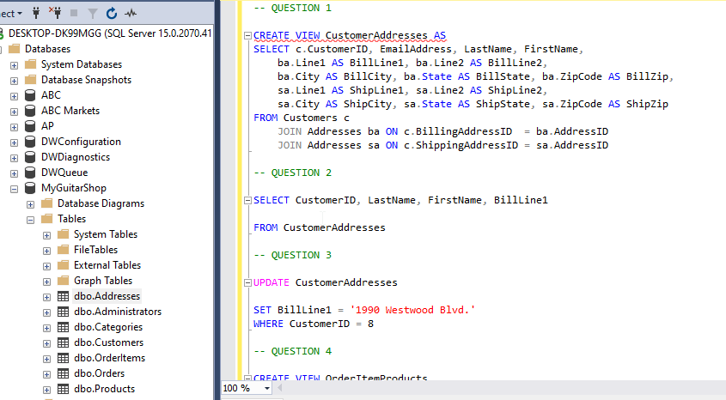

2. 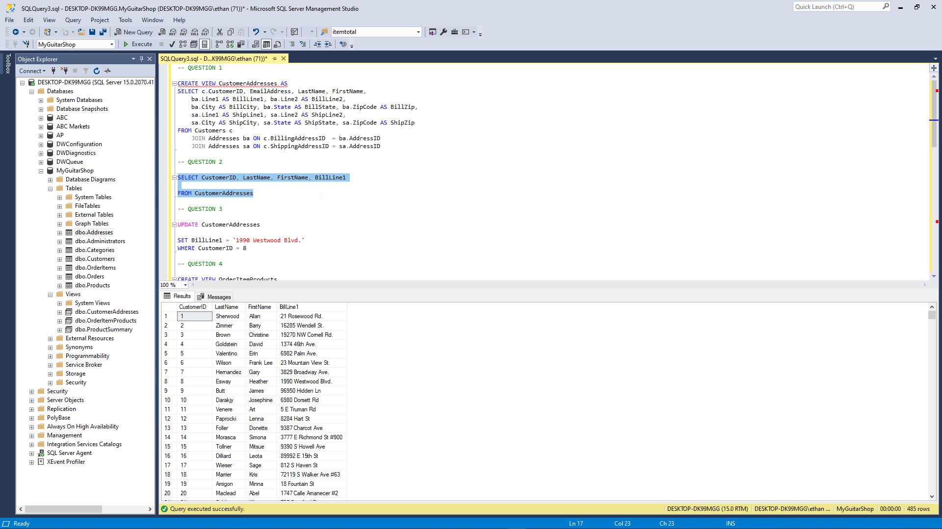

3. 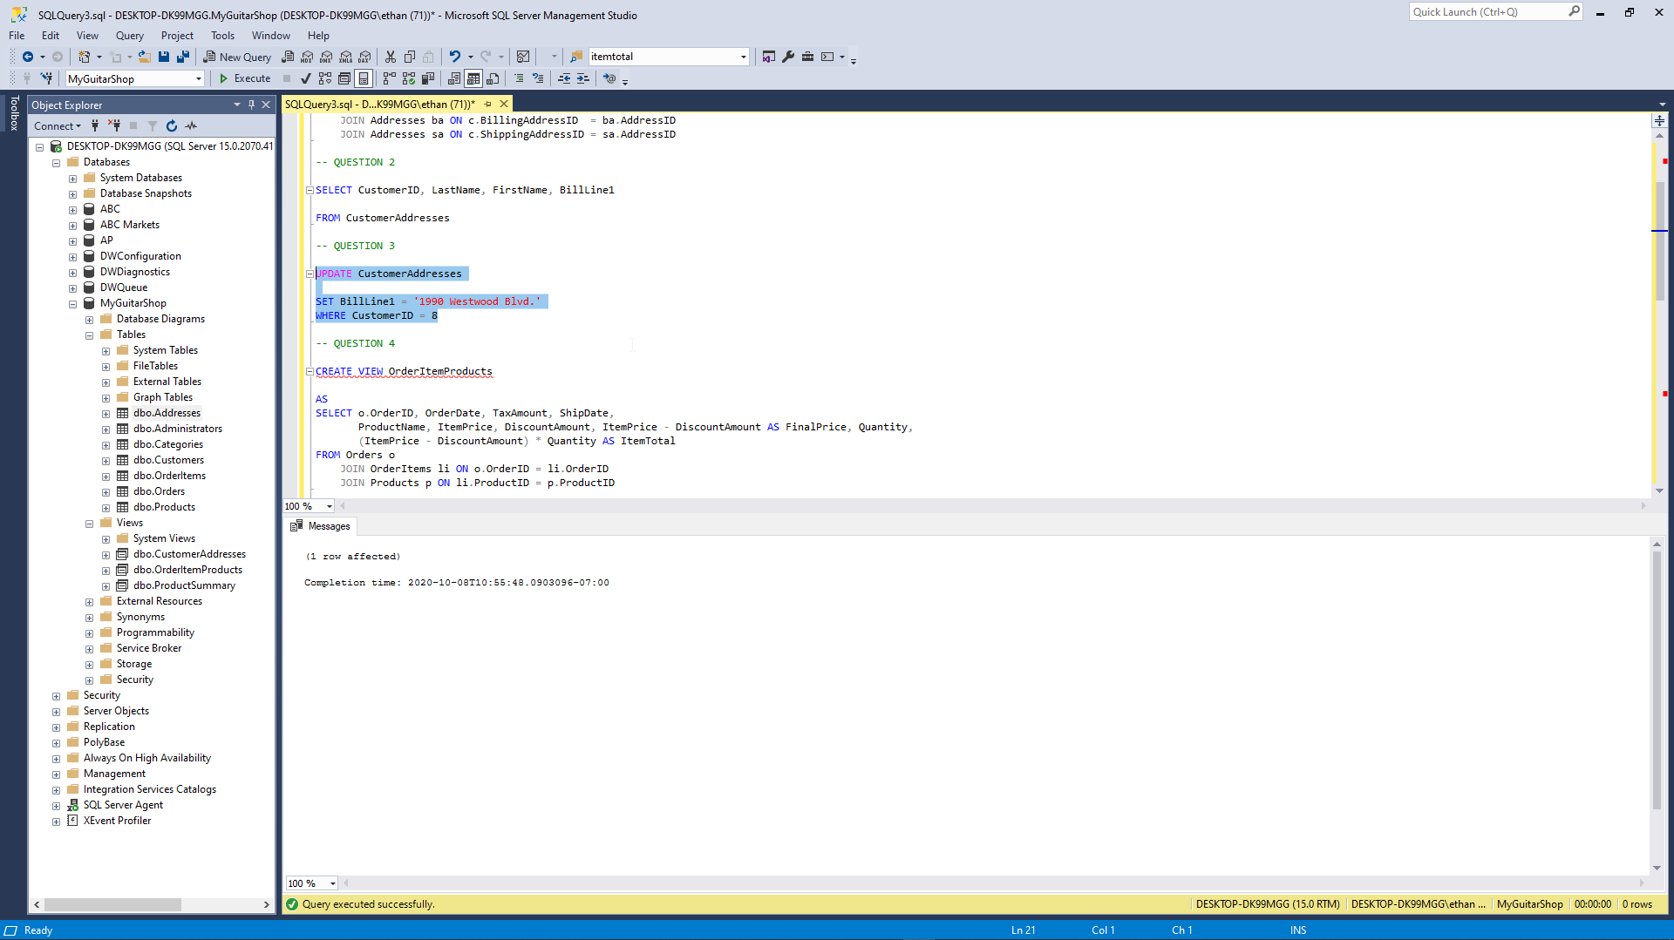

4. 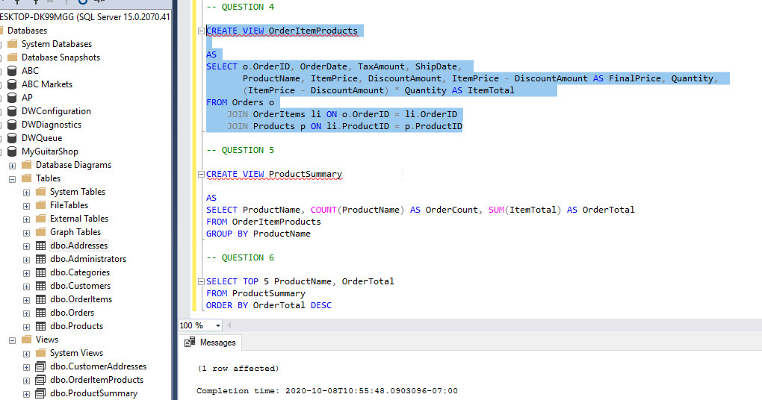

5. 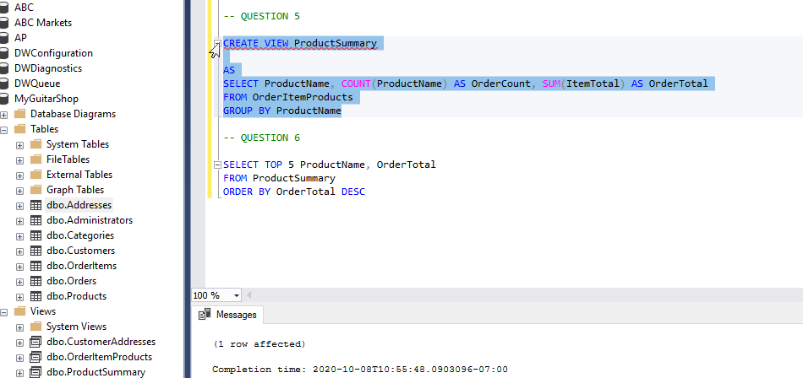

6. 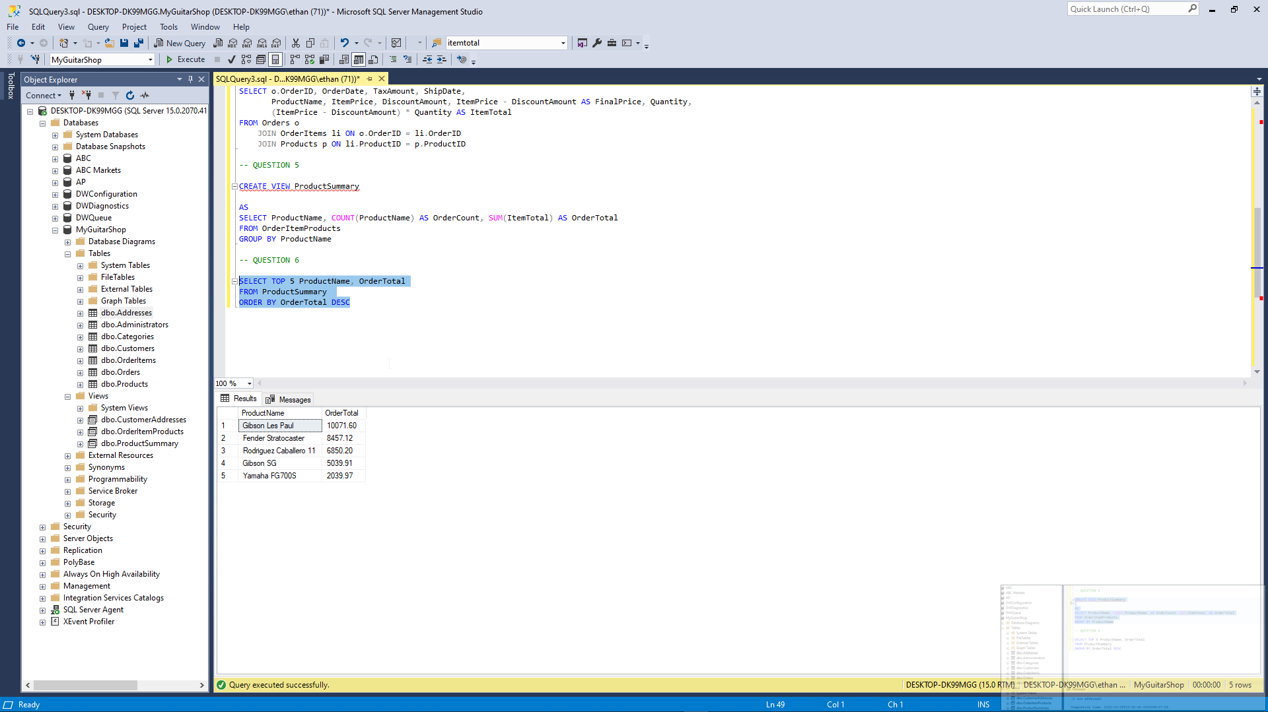

PART 3

1. 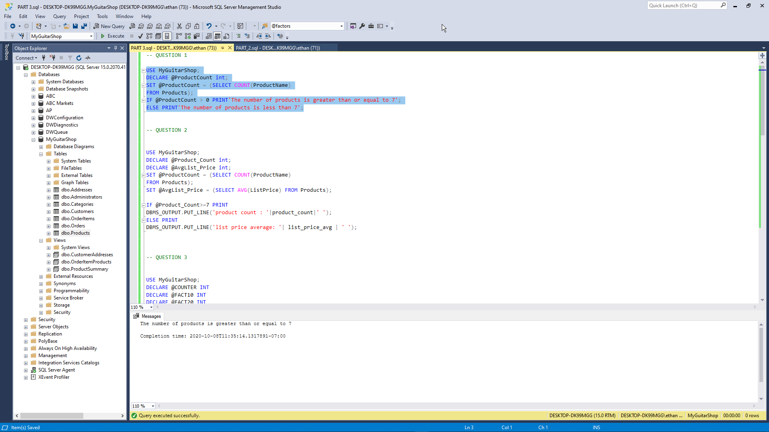

2. 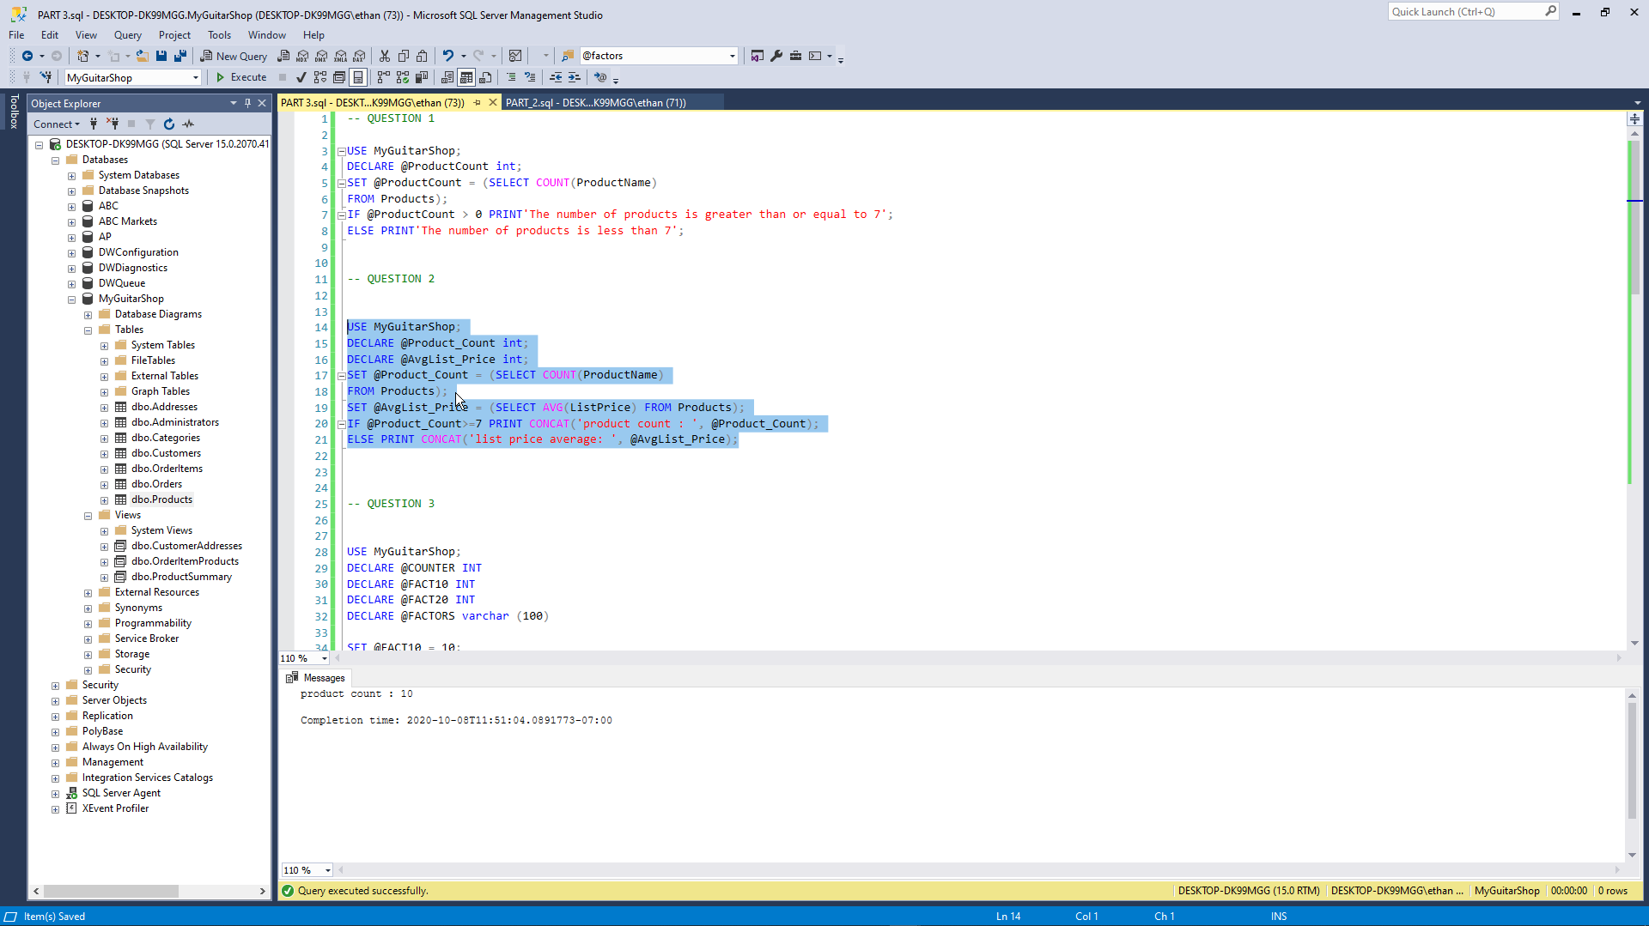

3. 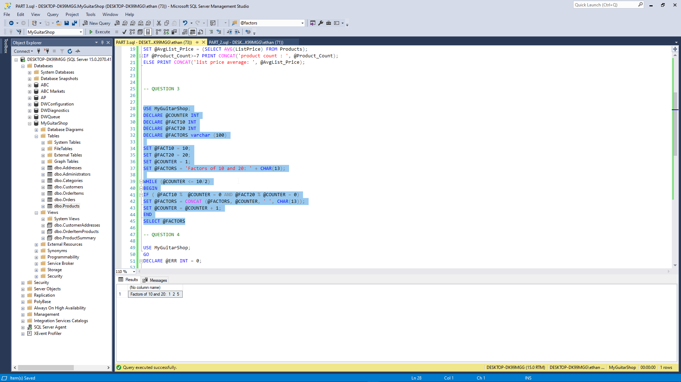

4. 